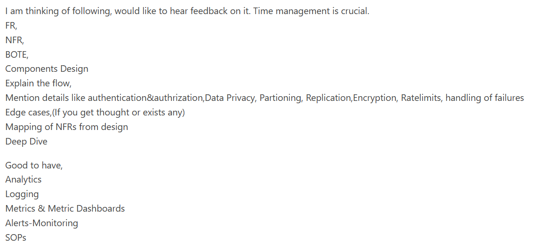
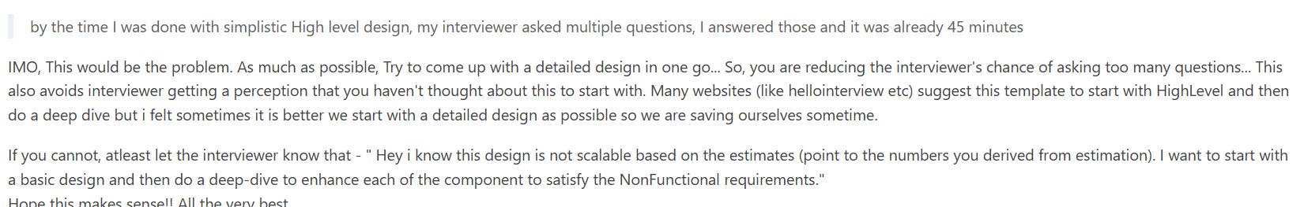

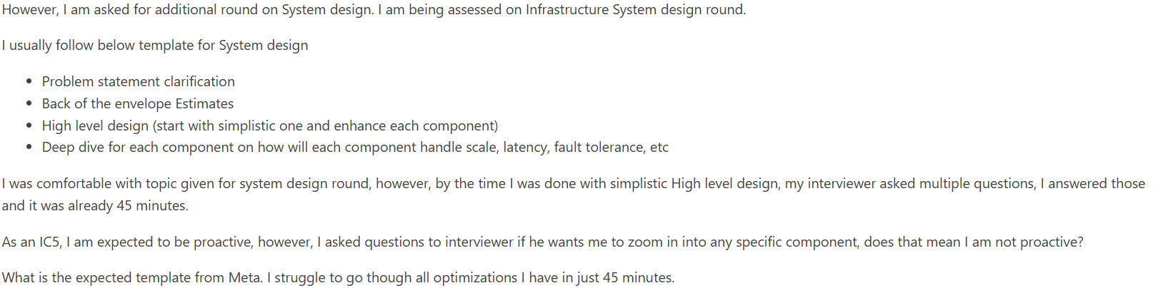
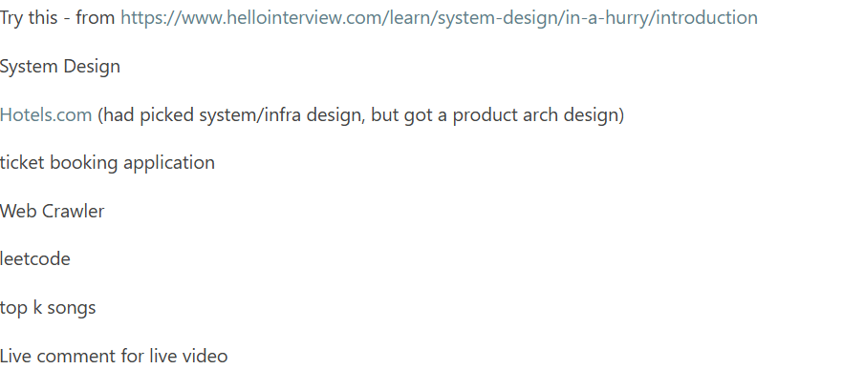

https://leetcode.com/discuss/interview-experience/4428743/Meta-Onsite-System-Design-Questions

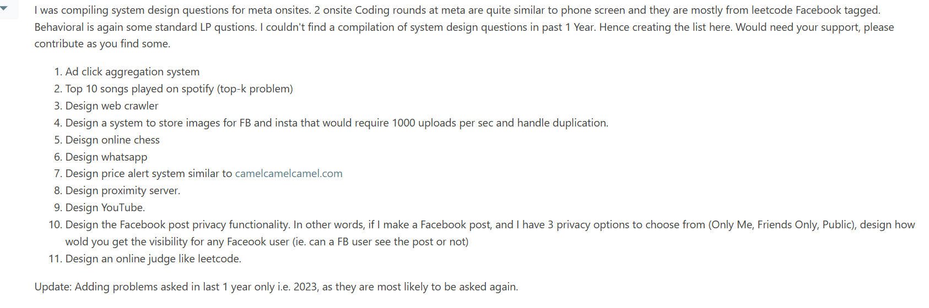

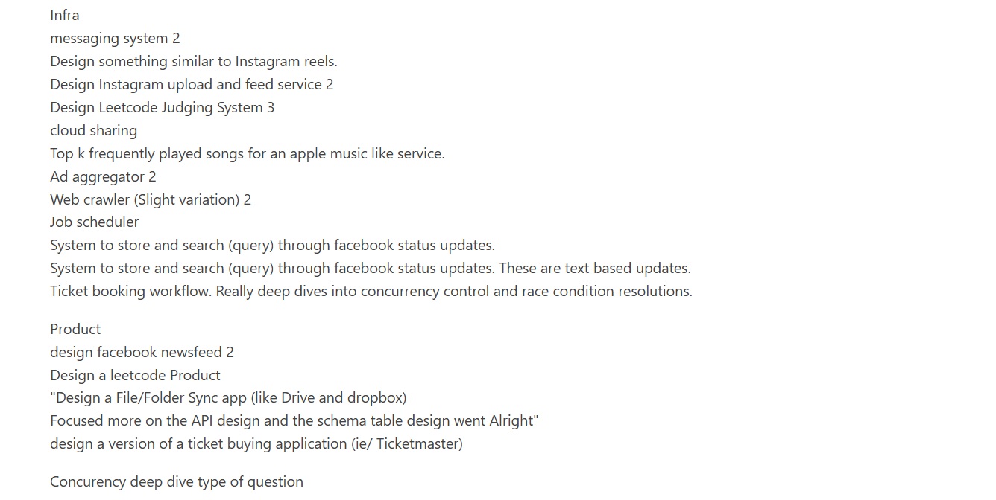


Design News Feed
Includes search, posts, and status
Top k heavy hitters
Design a distributed scheduler / web crawler

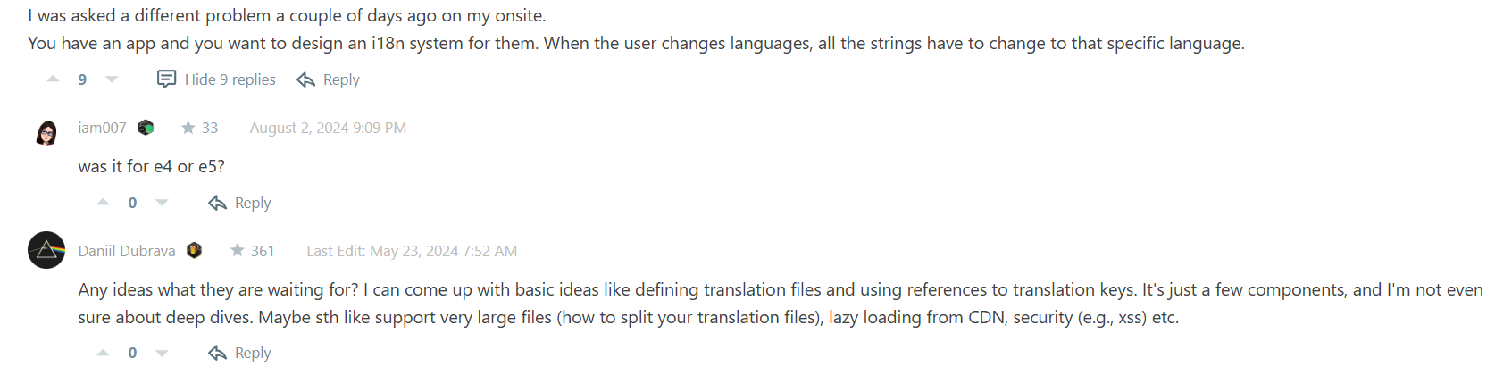


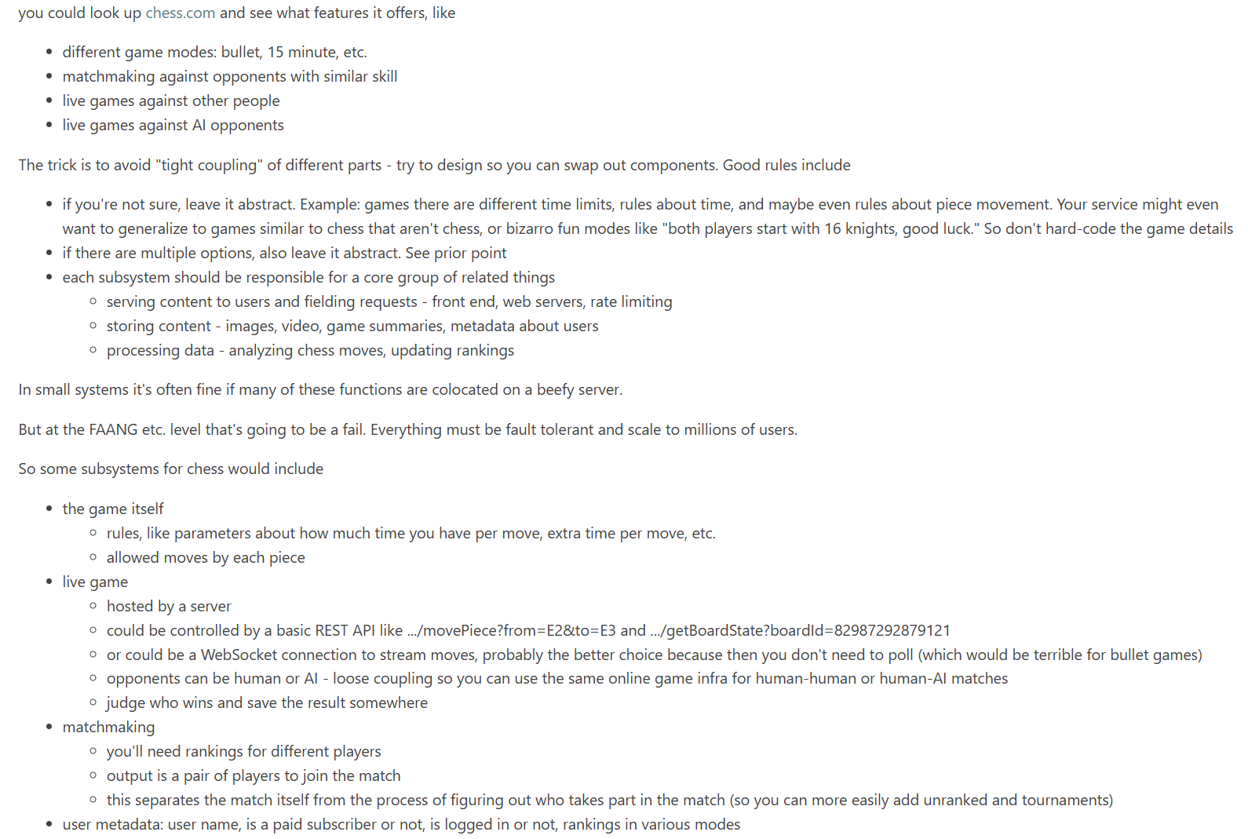

- Job Scheduler
- TicketMaster
- DropBox
- Design file downloader library probably like object storage.
- leetcode online judge problem.
- design netflix
- design yelp
- design messenger status
- Had my interview a few weeks back. Got asked to implement internationalization for static facebook other customer facing pages. How can we have developers code front-end pages in say English and users who have language preferences see it in that language.
- Design MemCache
- Update/set and search statuses of users. Search should support and and or operation e.g. "bat" and "ball" and "bat" or "ball".
- Design online gaming leaderboard
- proximity server
- design a system to get near by places from a location (very vague)
- need to satisfy 1million req per sec with min latency
- design facebook search
- Design metas newsfeed with live posts (like live videos)
- Design Privacy Settings At Facebook

Probably not. 1000 per second at 3 MB is roughly 100 PB.
How much would that cost in S3 bandwidth and storage costs?
How much would that cost if you did storage and serving yourself?
Hint: think of companies with massive data. Does Dropbox use S3? No. Does Google? No. Meta? No. But to be fair: Snapchat? Yes.

Diff btwn Ad click aggregator and top k songs played ( spotify ) – top-k-problem
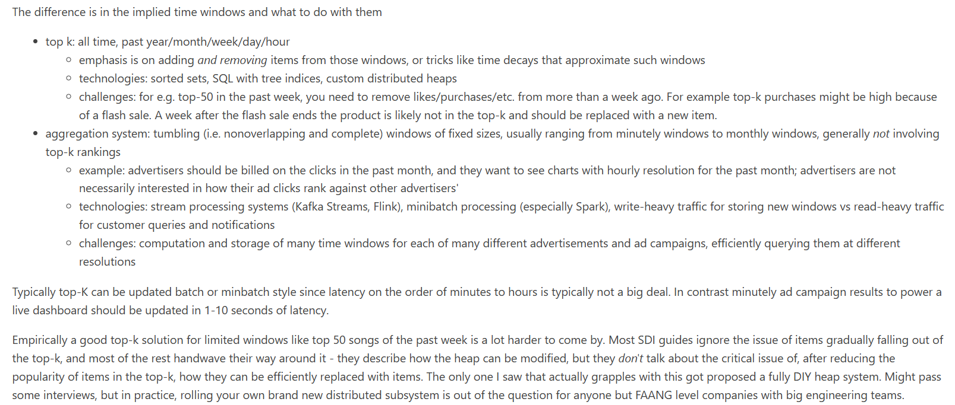

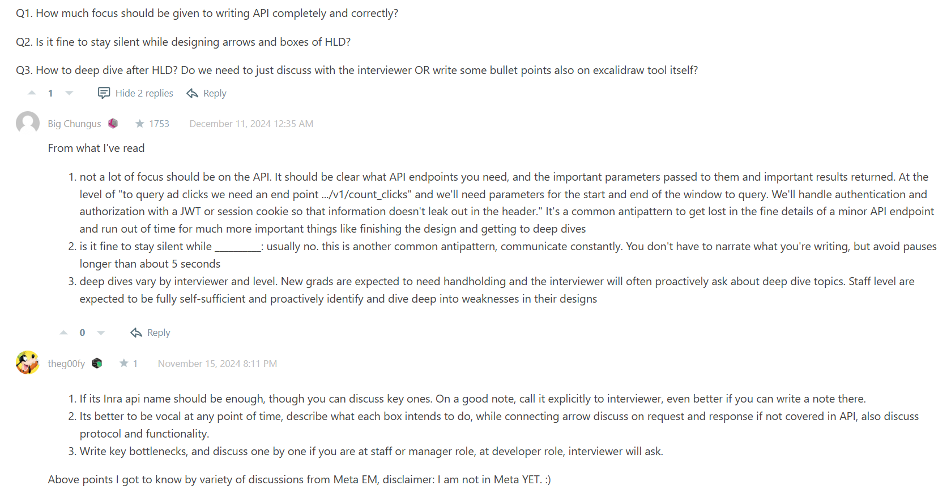
proximity server
design a system to get near by places from a location (very vague)
need to satisfy 1million req per sec with min latency.
Design to Store 1000 images per second
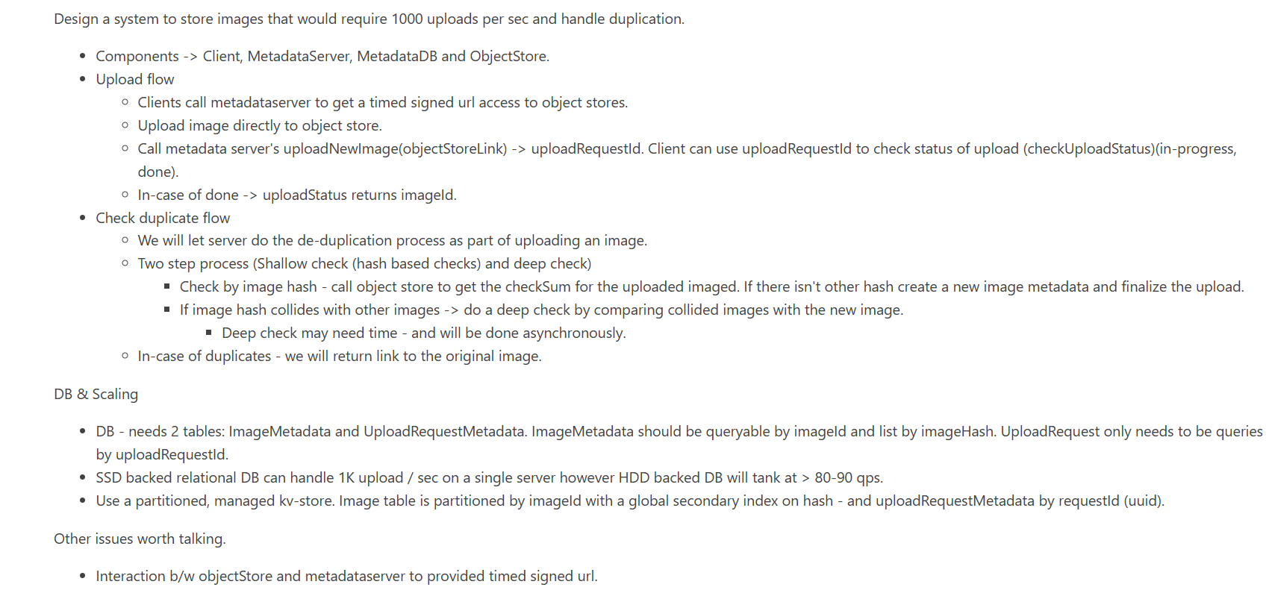

Explaining about the System design Interview
Usually the design interview has similar timing to the others, about an hour total, with 40-50 minutes for the design part.
System Design Interview and System Design Interview: Volume II by Alex Xu are classic books for preparation, I assume they're good for the the E3-E4 interview but I have yet to do one. They IMO focus a bit too much on front-end load balancing and low-level HTTP which isn't the "meat" of the design problem... but still good. It has several classic problems with full explanations.
The system-design-primer github repo looks promising, although I haven't spent much time with it. Lot of links though.
Otherwise I'd know about common strategies and products and patterns for the following, open-source and AWS/GCP/OCI products, for
- DNS and routing (sparing, a deep dive into DNS strategies is IMO too specific for a 40-50 minute overview)
- HTTP, and the common "layer 7 protocols" that use it
  - REST - definitely know GET, POST, PATH, DELETE (the most common HTTP verbs)
  - GraphQL - modern and more flexible than REST in many cases, designed at Facebook
  - protobuf - developed by Facebook's frenemy, Google, more for lower-level high performance IPC
- web servers
  - if you have lots of time, creating your own very basic web server from sockets is super instructive here
  - proxies and reverse proxies, aka load balancing and distributing requests to backend services as needed
- common data storage formats
  - SQL databases (Postgres)
  - document databases (MongoDB)
  - key-value stores (Redis)
  - key-blob stores (AWS S3)
  - durable logs (Kafka)
  - know when to choose each of these and why
  - know the access patterns for databases and how indexes, if available, speed up queries
  - scaling strategies for these: sharding, adding more nodes, federation
  - consistency vs. availability when failures occur
  - durability - generally even more important than availability. Usually you can tolerate 0.1% downtime, but data loss is nigh unacceptable
- distributed queues for async operations and decoupling services
  - Kafka (not ideal for work queues, but serviceable)
  - Redis streams
  - RabbitMQ
  - be familiar with durable (flushed to disk, sometimes even transactional) versus ephemeral queues
  - scaling strategies for queues, and durability options (flush after every write, periodic flush, pros and cons)
- estimating scale and planning accordingly
  - back-of-the-envelope estimation: know the powers of 10 for giga (1e9), tera (1e12), peta (1e15), exa (1e18)
  - memorize that a day has about 1e5 seconds in it (most calendar days have 86,400)
  - know some common details like an image is a few MB compressed, typical text compression rates are about 2.5-3, HD video streams at about 5 Mbps)
  - know common datacenter NICs (1-100 GbE, the latter being much more expensive than 1-10 GbE) and switches so you can estimate bandwidths and what's possible
  - have a plan for storing lots of data, because most SDI topics involve a big distributed service with lots of data
    - 1 GB - in memory, or any old DB, for metadata usually
    - 1 TB - single node, or in memory distributed across nodes, for text data for many users
    - 1 PB - one really big node, or distributed, not feasible in memory, for tons of text, or media
    - 1 EB - how Dropbox, Google Drive, etc. store exascale data, for 100M DAU scale media (many very powerful storage nodes)
    - data replication: replicas and/or erasure coding (RAID 5/6, Reed-Solomon, other error-correcting codes)? when should you use one vs. the other or both?
    - data access patterns - are all items accessed with the same frequency? Or are some items hot and others cold? How should hot vs cold data be handled?
  - have a plan for serving lots of data
    - 100 MB/s: can be served from one relatively beefy server
    - 1 TB/s: you're going to need on the order of a thousand cheap NICs for this = many hundreds of servers!
- caching, what kind to use and when to use it
  - local caching, same node
  - in-memory caching, Redis/Memcached/etc.
  - SSD caching in the datacenter
  - CDNs, in-memory and SSD caching close to users
- a sense of what kinds of APIs you need for storing data, retrieving it, CDN caching
- misc other items that are generally helpful, but usually tangential
  - security: login, authentication, security tokens
  - rate limiting
  - logging and metrics

“I failed because of estimations.” - In systems round they can ask anything related to linux kernel and OS. There is no set syllabus. There are some git repos for Meta PE. I would refer those.

https://igotanoffer.com/blogs/tech/meta-system-design-interview
https://github.com/bhavul/System-Design-Cheatsheet
https://www.dezyn.io/shared/d959b201-de35-403c-892c-fc7c435befe5
https://gist.github.com/mwakaba2/8ad25dda8c71fe529855994c70743733
- above back of the envelope calculations

- creates System Design flow by the prompt
Meta focuses on your ability to understand the basic system design primitives and does not care much about specific technologies. Most problems are about "scale" rather than "knowledge". They also focus on your ability to :
- Are you able to understand the requirement and what it means for your design. (Which part of the requirements are the real challenge?)
- Non functional requirements where you do basic math about storage, bandwidth etc.
- Ability to clearly articulate your thoughts, ask questions.
My tip always is to have following template to talk.
I think one way to design this is X, another way to design this is Y, the trade off here is this and this but given requirements I think it is better to pick X over Y for these reasons.

Leetcode
System Design:
Judge system like Leetcode
Basiclly
User->LB->SubmissionService->Kafka->Workers->MySql tables
tables :
User / Problems/Testcases/Contest/Submission
Two follow up questions :
-control random generated submissions : rate limiting using redis HashMap
-Will u use the same worker for running all code types:
I choosed to make it worker per programming lang to control custom setting / scalability options per Language.

